Asif subhan Asif subhan, Ricky Sanders, Evan Simmons, Meng Qi

asubhan@uncc.edu

Abstract

The purpose of this document is to explain each part of the website in details

User manual

Instructions for how to use X Note Plus

# 

Table of Contents

About X Note Plus 2

Create an account 3

Upload Notes 4

My Account 5

My Files 5

My Profile 5

Study guide 6

Search 7

Rating System 8

Rating Documents 8

Rating Study Guide 8

# About X Note Plus

We are a group of students of University of North Carolina at Charlotte. This website is designed for our senior capstone class. As a group we decided to make a website where students from around the word could use it to upload notes, share notes, and compare notes. This website provide student’s opportunities to look up similar notes, get study guide and see other peoples rating.

# Create an account

For uploading and comparing purposes this website uses user account info to keep track of every notes and class study guide. In order to use this website please register as shown below.

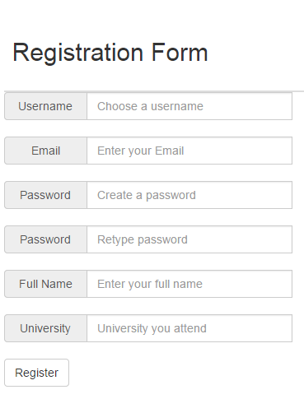

* All of the fields are required in the registration form. You should get an email after registration.
* **NOTE:** It is suggested to use an account that has already been populated with files to test the full functionality of the website so that you do not have to waste time populating your account with files. The recommended login to use is:  
  Username: Ricky  
  Password: pass

# Upload Notes

Use the upload page to upload notes and save it.

* All fields are required as shown in the following figure.
* You must be logged in before uploading a file
* Upload only .txt files

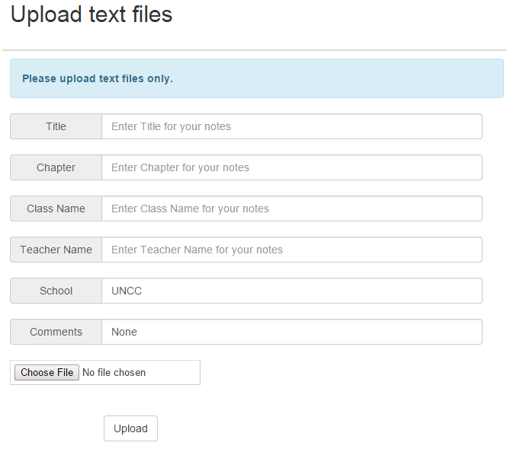

# My Account

My account page where the user will find most of the important information. My account page include My Files, Profile, and Study guide.

## My Files

This page shows all the files of the current user. This is the first and the default tab for My Account page. It displays File name and Notes Title. The user has the option to View, Download, Delete, and View similar files by clicking one of the action buttons.

* Action Buttons
  + 
    - This button will allow the user to view their file
  + 
    - This button allows the user to download their file as a pdf
  + 
    - This button lets the user delete their file
  + 
    - This button allows the user to see files that are similar to their file

## My Profile

Click on Profile tab to go to Profile Tab.

The profile page display the all the information about a user such as user name, full name, School etc. if a user chooses to update information simply enter new information in profile form.

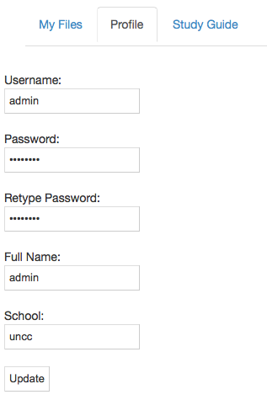

## Study guide

* Allows user to view study guides for classes that they have uploaded notes for
* Action buttons
  + 
    - This button will allow the user to view the study guide
  + 
    - This button allows the user to download the study guide as a pdf

# Search

* Using the side bar simply enter the title of the document you are looking for

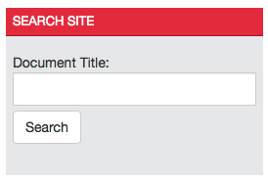

* Select the “Search” link on the main menu
  + Enter the document Title in the field shown below
  + Select Search to see results

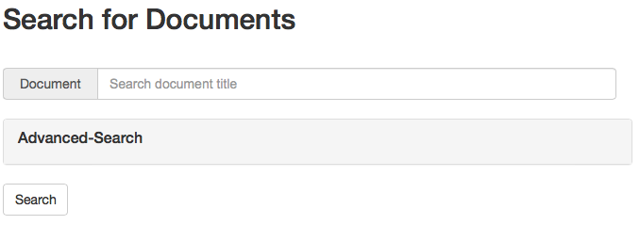

* + To find a wider range of documents, select the Advance search button
  + You must enter at least one field
  + Then select search to see results

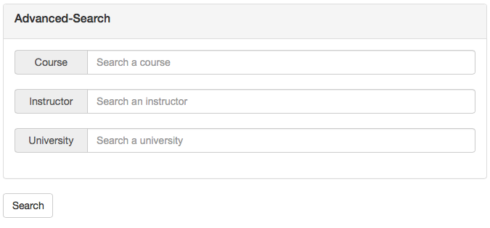

# Rating System

## Rating Documents

To rate a document, navigate to that document by either Searching for the document or by selecting “My Account” - “My Files” - View

* Hit  to like the file
* Hit  to dislike the file

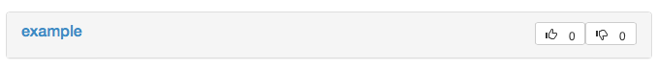

* Users can not select the same button multiple times for the same document

## Rating Study Guide

To rate sentence in the study guide, navigate to the class study guide by selecting “My Account” – “Study Guide” - View

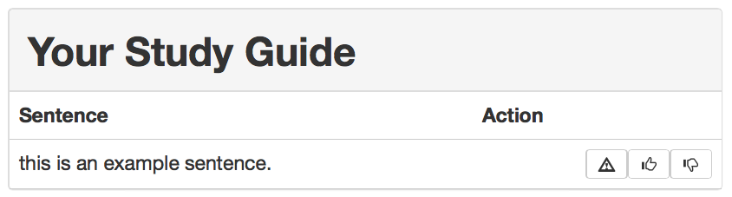

* Hit  to like the file.
* Hit  to dislike the file.
* Hit  to report abuse.